NAME: …………………………………………………… SIGNATURE……………



P530/1

**BIOLOGY**

Paper 1

2.5 HOURS

**END OF TERM ONE ASSESSMENTS**

**S.4 BIOLOGY (Theory)**

Paper 1

**Instructions to candidates**

* *Answer* ***all*** *items in section A and 1 in part 1 plus 1 in part 2 of section B*
* *Answers in section A should be put in the boxes provided at the right side of the question paper.*
* *Try your level best to write well*

Examiners’ use only

|  |  |
| --- | --- |
| **SECTION** | **MARKS** |
| **A** |  |
| **B** |  |
| **TOTAL** |  |

**SECTION A**

1. James a 5 year old boy was moving with his father Anthony through their herd. On his surprise as a young boy, he saw cattle chewing food in its mouth yet the cow had spent the whole night locked in a place without food. He decided to find out how this is possible yet for him he could not chew his mouth without having had a meal.

He tasked his father to help him explain this.

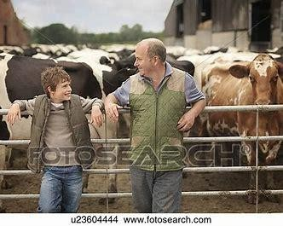

* 1. Briefly explain what his father could have told him.

....................................................................................................................................................... ....................................................................................................................................................... .......................................................................................................................................................

.......................................................................................................................................................

.............................................................................................................................................

* 1. If the boy copied that behavior of chewing his mouth without food for a month, how is his stomach most likely to be affected?

....................................................................................................................................................... ....................................................................................................................................................... .......................................................................................................................................................

...............................................................................................................................................

1. In a certain region, famine outbreak became worse in 1980 due drought. Many people did not survive. Most of them grew thin, others became dwarf, and children developed kwashiorkor and rickets while others developed poor eyesight. This created worry and fear in the whole community. People started praying so that it rains for them to plant crops containing nutrients that could rescue their nutrition problems.
   1. Identify the crops you would advice these residents to grow giving reasons to your answer as per table.
   2. How can they ensure the growth to be faster and produce high yields?

**crop**

**reason**

....................................................................................................................................................... ....................................................................................................................................................... .......................................................................................................................................................

.......................................................................................................................................................

.......................................................................................................................................................

...........................................................................................................................................

* 1. Apart from crop growing, which other farming activity do you advise them to practice so as to solve their nutrition problems.

.......................................................................................................................................................

...................................................................................................................................................

1. Gabriel is a great farmer in outskirts of a certain area. He practices crop husbandry on irrigation system basis. He decided to employ some workers to weed his maize garden. During the weeding activity, one of the workers cut the root system of one plant. By the time they came to the end of the garden. The plant had started drying with leaves drooping.

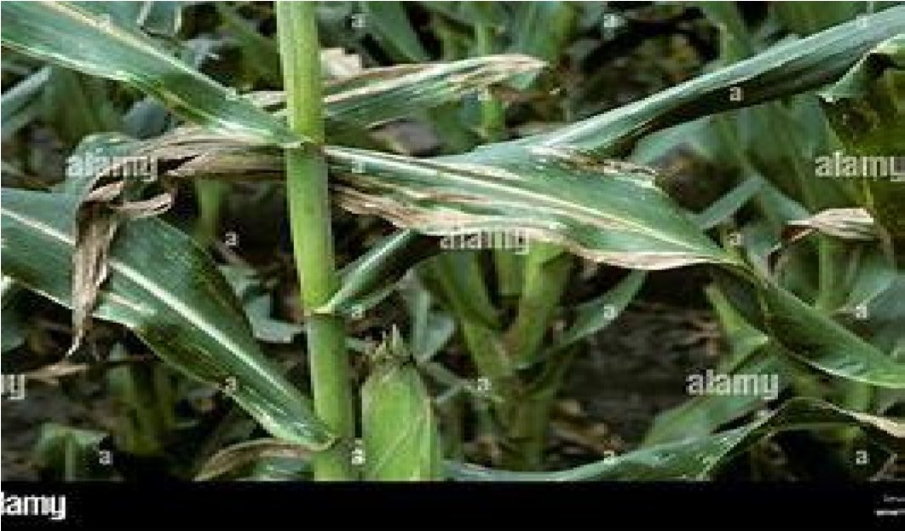

* 1. Explain the major process that occurred in the shoot system that caused plant leaves to dry

....................................................................................................................................................... ....................................................................................................................................................... .......................................................................................................................................................

...............................................................................................................................................

* 1. State the factors that affect the process identified above.

....................................................................................................................................................... .......................................................................................................................................................

.......................................................................................................................................................

.......................................................................................................................................................

.............................................................................................................................................

* 1. Identify the failure of the root system that caused drying of plant.

.......................................................................................................................................................

...................................................................................................................................................

**SECTION B**

**Part 1 (attempt only 1 item)**

1. Mr. Okumu is organizing a colorful silver jubilee celebration in marriage. He is looking for a competent person who can decorate his home compound 5 days before the occasion day. He is interested in mostly using natural plants which are as below.

If you the competent person chosen.

**Task:**

W

hich

type and modes

of reproduction would you use

to beautify his

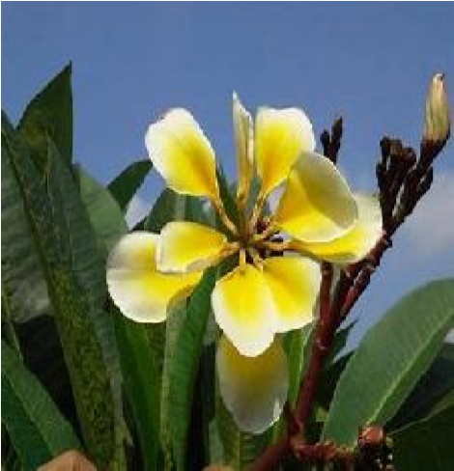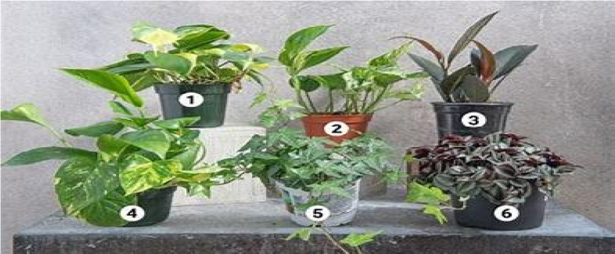

compound? State the advantages and disadvantages of the type of reproduction chosen to use in beautification.

1. Janet was moving with her mother to garden. They encountered different organism which were as in the figure below. Janet was an active growing child who had

curiosity of finding out the names of these organisms.

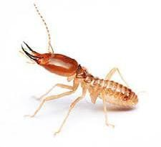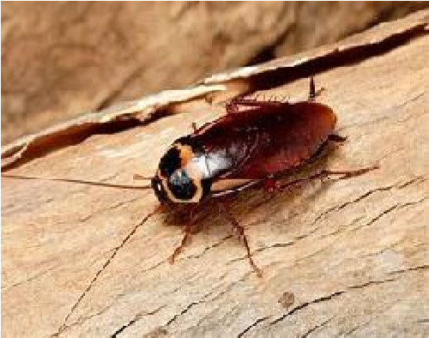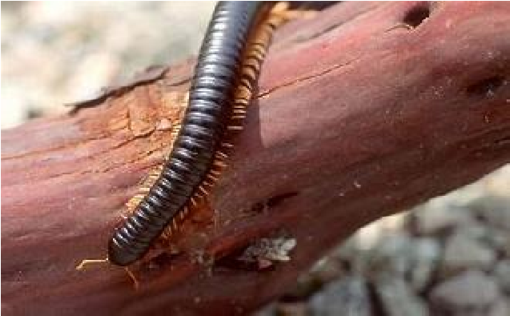

* 1. If you were the mother with some knowledge of scientific classification, what could you tell this child beginning from kingdom to class?
  2. What are the benefits of the first organism to the soil? **Part 2 (attempt only 1 item)**

1. The key problem in Katwe farms is the poor crop yields from their land. The residents organized and invited a soil science specialist to come and give them a piece of advice. His analysis showed that the soil pH could be the major issue. However he was interested to pick soil sample from the farmlands and take it to the laboratory for sampling.

**Task**: If you were the invited specialist, describe how you would conduct the experiment to obtain correct results. State your advice to the residents

1. In preparation for inter-class competition, starling a 40 kg male athlete ate a meal containing 470g of carbohydrates in the morning. She believes that the meal will enable her perform better during the competition. However her young brother dose not seems to understand how the meal will contribute to competition. Starling finally won the competition but experienced muscle cramps. she rested for 20minutes, returned home walking but the brother wondered how he still had the strength to walk home after the competition.

**Task:** Explain to starling’s brother the processes that the meal he ate went through to enable her win the race, be able to come back and how her body regained the normal state